The Kindred Supply: A Strategic sales and revenue
Analysis


This report aims to generate insights into customer behavior, sales patterns, and employee performance to aid decision-making processes. It will cover sales analysis, customer segmentation, inventory trends, and employee performance, consolidating data from multiple tables for a comprehensive view of the company's operations. The report will empower stakeholders to make data-driven decisions by offering valuable insights and facilitating data exploration through interactive visualizations and dynamic filters.
We have below tables
Customers Table
This table stores information about the company's customers. It includes fields for customer ID, company name, contact name, contact title, address, city, region, postal code, country, phone, and fax.
Employees Table
This table stores information about the company's employees. It includes fields for employee ID, last name, first name, title, title of courtesy, birth date, hire date, address, city, region, postal code, country, home phone, extension, photo, notes, reports to, and photo path.
Orders Table
This table stores information about the company's orders. It includes fields for order ID, customer ID, employee ID, order date, required date, shipped date, ship via, freight, ship name, ship address, ship city, ship region, ship postal code, and ship country.
Order Details Table
This table stores detailed information about the items within each order. It includes fields for order ID, product ID, unit price, quantity, and discount.
Products Table
This table stores information about the company's products. It includes fields for product ID, product name, supplier ID, category ID, quantity per unit, unit price, units in stock, units on order, reorder level, and whether the product is discontinued.

Suppliers Table
This table stores information about the company's suppliers. It includes fields for supplier ID, company name, contact name, contact title, address, city, region, postal code, country, phone, fax, and home page.
Shippers Table
This table stores information about the company's shipping companies. It includes fields for shipper ID, company name, and phone.
Categories Table
This table stores information about the product categories. It includes fields for category ID, category name, and description.
- Step1-Data cleaning
Cleaned all CSV files as stated below and then saved as CSV,converted all primary key in string form.
1.Customers –
- Deleted image and image thumbnail columns
- changed 1 st row as header
- Replaced multiple blank values in Region column with other
2.Suppliers-
- deleted links column
- Replaced multiple blank values in Region column with other
3.Orders-
- In Shipregion column Replaced multiple blank values in Region column with other
- Change datatype of all date related columns to date
4.Orderdetails-
- Created ‘totalamount’ column
- Where totalamount=price*quantity-discount*price*quantity
5.employees-
- Deleted photo column

Step3-EDA in Mysql
Imported 8 files in mysql workbench, performed EDA for 15 different Questions
- What is the average number of orders per customer? Are there high-value repeat customers?
- How do customer order patterns vary by city or country?
- Can we cluster customers based on total spend, order count, and preferred categories?
- Which product categories or products contribute most to order revenue? 5 .Are there any correlations between orders and customer location or product category?
- How frequently do different customer segments place orders?
- What is the geographic and title-wise distribution of employees?
- What trends can we observe in hire dates across employee titles?
- What patterns exist in employee title and courtesy title distributions?
- Are there correlations between product pricing, stock levels, and sales performance?
- How does product demand change over months or seasons?
- Can we identify anomalies in product sales or revenue performance?
- Are there any regional trends in supplier distribution and pricing?
- How are suppliers distributed across different product categories?
- How do supplier pricing and categories relate across different regions?

Step4-EDA in excel
- Imported same 8 cleaned datasets in excel, cleaned them in power query if necessary ,then I add them to data model .In power pivot ‘manage relationship’ section I performed data modelling ,joined those table together on their primary and foreign keys,here I used one to many relationships.
- Created data dictionary for files
- After that I pasted each questions sql code and output window beneath it and then tried to find out same answer in pivot table ,then performed charting of final output
Our Excel Analysis-

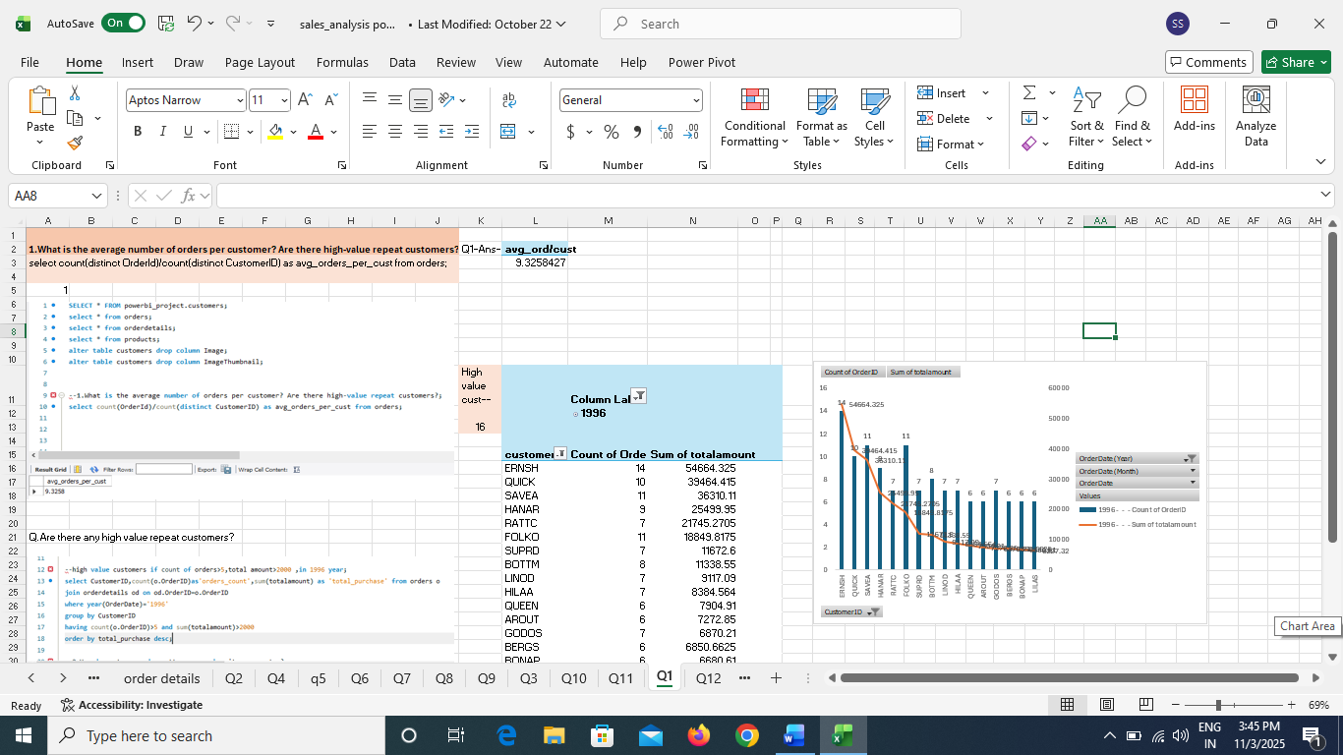

Step5-EDA in power bi
- Imported same 8 cleaned csv files in powerbi, performed if more cleaning is needed in power Query editor
- Changed data type if needed.
- Created calculated columns, Measured columns if needed.
- Created ‘bins range’ columns for different histograms
- Made use of different types of charts as requirement like line chart,scatter chart,clustered bar/column,stack bar/column chart,map chart ,box plot chart etc
- Finaly made a appealing Dashboard out of that insights.

Here are our Business Questions-
- How does customer distribution vary across different countries or cities? Use bar chart or map to visualize.
- What is the trend in customer orders over time? Use line chart or area chart to visualize.
- What is the distribution of customers by Contact Title or Region? Use stacked bar chart or pie chart to visualize.
- How does order volume change over time? Use line chart or stacked bar chart to visualize.
- What is the distribution of order values? Use histogram or box plot to visualize.
- What is the average order shipping duration? Use bar chart or box plot to visualize.
- What is the count of employees by job title or region? Use stacked bar chart or tree map to visualize.
- What is the distribution of employee tenure? Use histogram or box plot to visualize.
- What is the reporting structure among employees? Use org chart or hierarchical tree to visualize.
- Which products have the highest sales volume? Use bar chart or tree map to visualize.
- How does the sales volume vary across different product categories? Use stacked bar chart or tree map to visualize.
- Can we visualize the pricing distribution of products? Use box plot or histogram to visualize.
- How many products are supplied by each supplier? Use bar chart or pie chart to visualize.
- How does product pricing vary across different suppliers? Use box plot or stacked column chart to visualize.
- What is the geographical distribution of suppliers? Use map chart or bubble map to visualize.
Here is our ER diagram- *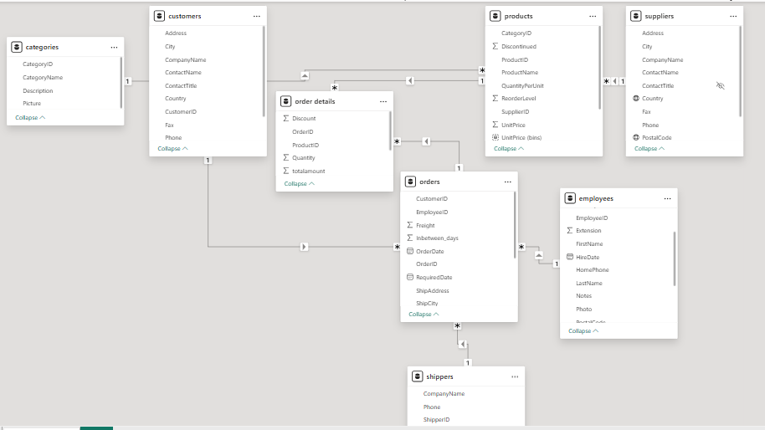
Here is our Northwind Traders Sales Analysis Dashboard 1-
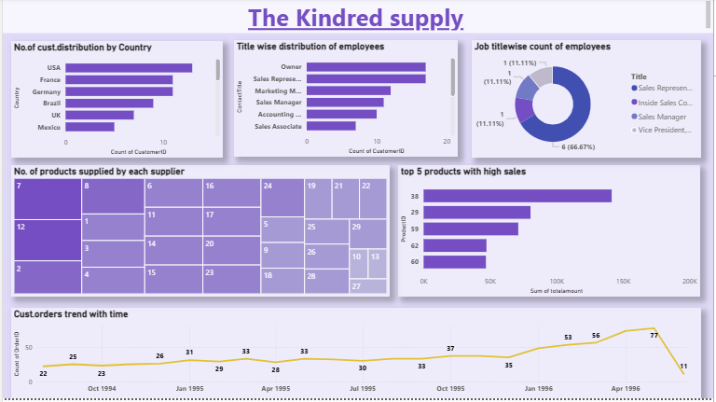

Here is our Sales Analysis Dashboard 2-
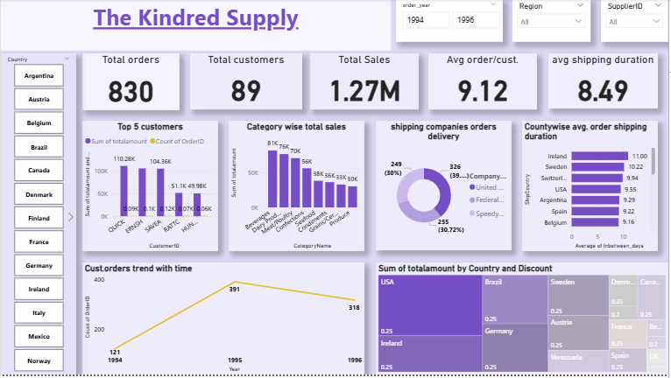

Here is our Sales Analysis dashboard 3-
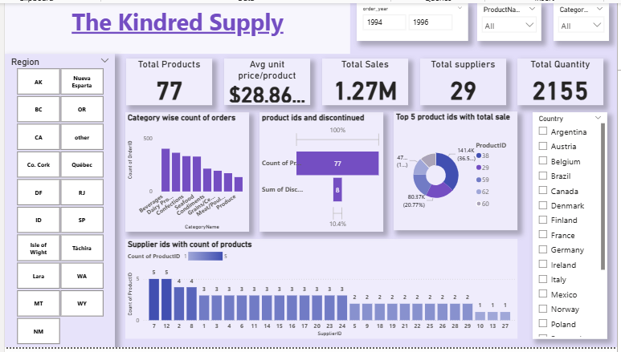

Conclusion-
The Northwind Traders Sales Analysis project successfully integrated and analyzed data from multiple sources — including customers, orders, products, suppliers, and categories — to generate meaningful business insights. Through structured data cleaning and transformation in Excel and SQL, inconsistencies were resolved, and relationships across datasets were clearly established.
Exploratory Data Analysis (EDA) revealed key sales trends, customer purchase patterns, and product performance indicators. Power BI visualizations provided an interactive and dynamic dashboard that allows stakeholders to explore sales by region, category, and time period, monitor employee performance, and identify high-value customers and top-selling products.

